Cairo University  
Faculty of Computers and Information



**CS251**

**Software Engineering I**

Adwarlak

Software Design

Mostafa Mohamed Amin

Islam Samir

Mahmoud Ahmed Mostafa

Shrouk Sobhy

Amira Shawky

December/2017

Contents

Instructions [To be removed] 3

Team 3

Document Purpose and Audience 3

System Models 3

I. Class diagrams 3

Important Algorithm 5

II. Sequence diagrams 5

Class - Sequence Usage Table 7

Ownership Report 8

Policy Regarding Plagiarism: 8

References 8

Authors 8

# Team

|  |  |  |  |
| --- | --- | --- | --- |
| **ID** | **Name** | **Email** | **Mobile** |
| 20150257 | Mostafa Mohamed Amin | Mostafa_amen07@yahoo.com | 01201393593 |
| 20150234 | Mahmoud Ahmed Mostafa | Mahmoudaldibawy@gmail.com | 01273046643 |
| 20150133 | Shrouk Sobhy Abdelrahman | [Shroukksobhy@gmail.com](mailto:Shroukksobhy@gmail.com) | 01286011876 |
| 20150064 | Amira Shawky Mahmoud | [Amirashawkym23@gmail.com](mailto:Amirashawkym23@gmail.com) | 01015511591 |
| 20150052 | Islam Samir Mohamed | [Rihdmagk0111@stud.fci-cu.edu.eg](mailto:Rihdmagk0111@stud.fci-cu.edu.eg) | 01116363580 |

# Document Purpose and Audience

* **This document is an illustration for the design of the software Adwarlak which provides the needed information about the classes structure and interactions making it easier to understand the software and how it works**
* **This document is targeted to the project manager, software developers and the customer.**

# System Models

## I. Class diagrams

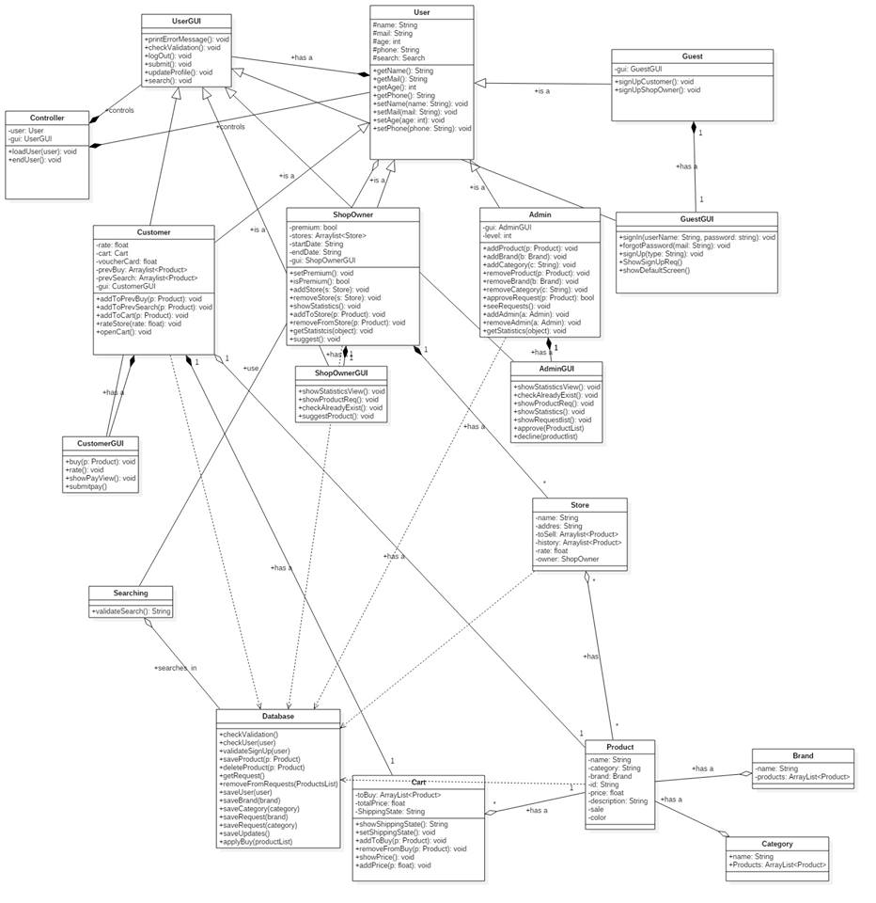

| **Class ID** | **Class Name** | **Description & Responsibility** |
| --- | --- | --- |
|  | User | The parent class which has all the shared information between the four types of users in the system. |
|  | ShopOwner | Holds the data corresponding to the shop owners in the system allowing them to has stores and do a lot of other functionalities. |
|  | Customer | Holds the data corresponding to the customers in the system allowing them to search for and buy products and do a lot of other functionalities. |
|  | Admin | The user responsible for the system with all the authorities to access the database and manipulate its data |
|  | Guest | The default state in which the user of the system starts and he can only search, sign in or sign up |
|  | UserGUI | Responsible for the basic gui in the system |
|  | ShopOwnerGUI | Responsible for the gui concerned with the shop owner allowing it to access its full functionalities in ease |
|  | CustomerGUI | Responsible for the gui concerned with the customer allowing it to access its full functionalities in ease |
|  | AdminGUI | Responsible for the gui concerned with the admin allowing it to access its full functionalities in ease |
|  | GuestGUI | Responsible for the gui concerned with the guest allowing it to access its full functionalities in ease |
|  | Controller | Responsible for controlling which kind of user is currently active and which GUI is displayed |
|  | Searching | Responsible for handling the search activity and making the queries that the data base uses |
|  | Database | The class that access the data base with the queries and returns the data if needed by another class |
|  | Product | Holds the information of a product when needed to make any kind of functionality on it |
|  | Store | Holds the products that the shop owner sells and the customers buy allowing them to do what they wanted by using the system |
|  | Brand | Holds a lot of products and categories making the search easier |
|  | Category | Holds a lot of products making the search easier |
|  | Cart | Hold list of products that the customer want to buy making it easier for him to buy products at once |

## II. Sequence diagrams

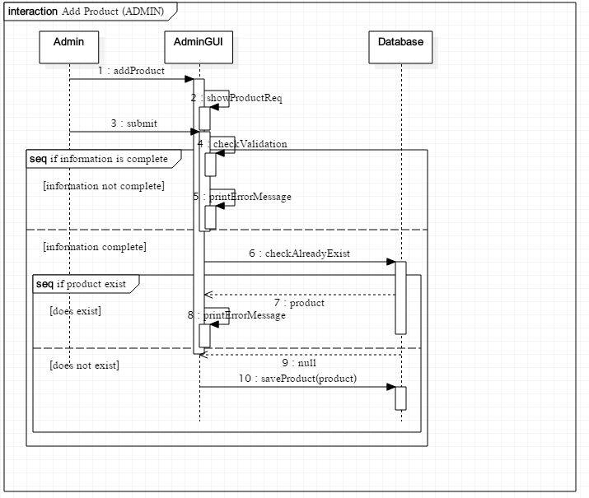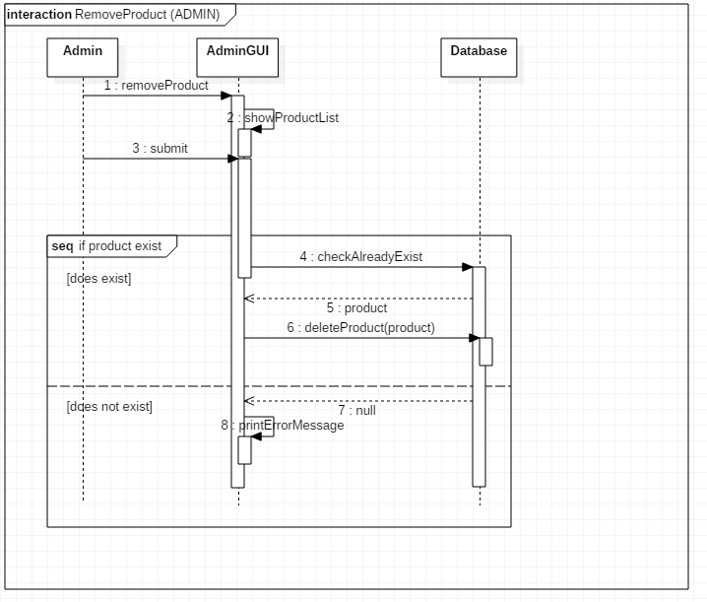

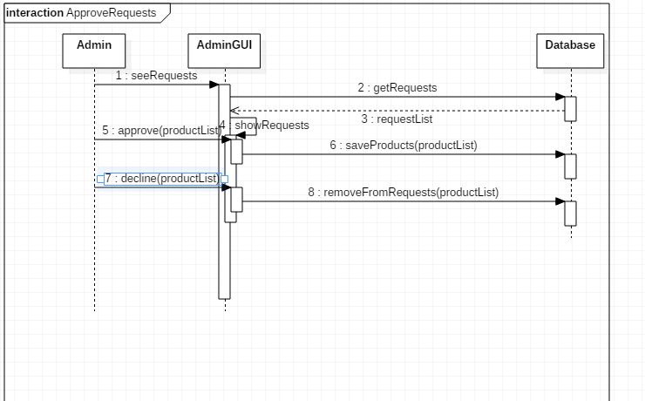

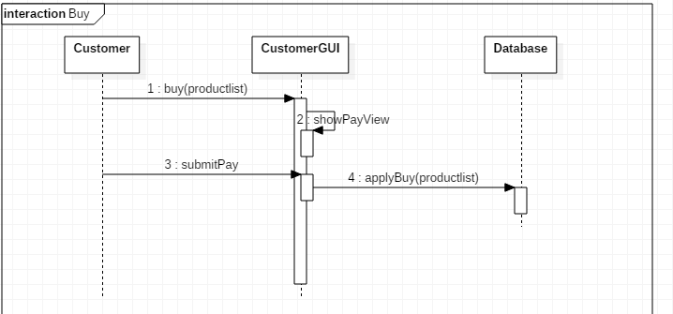

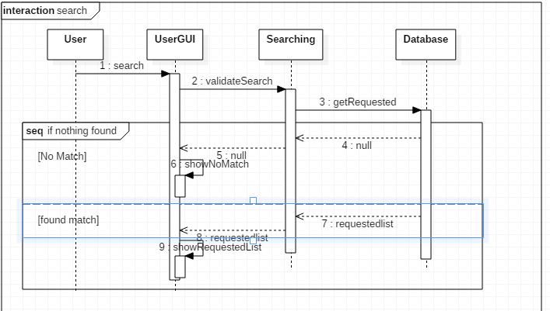

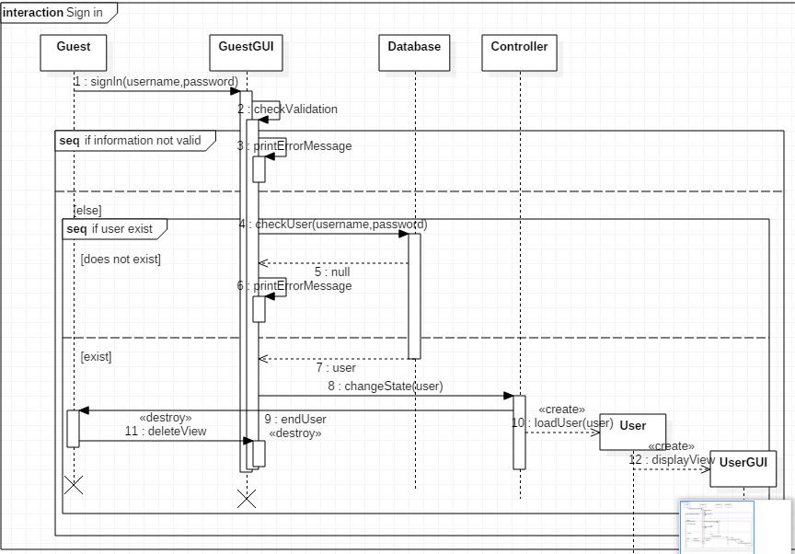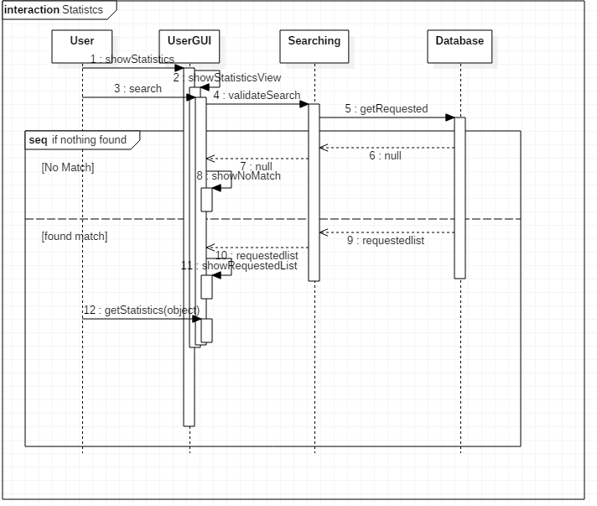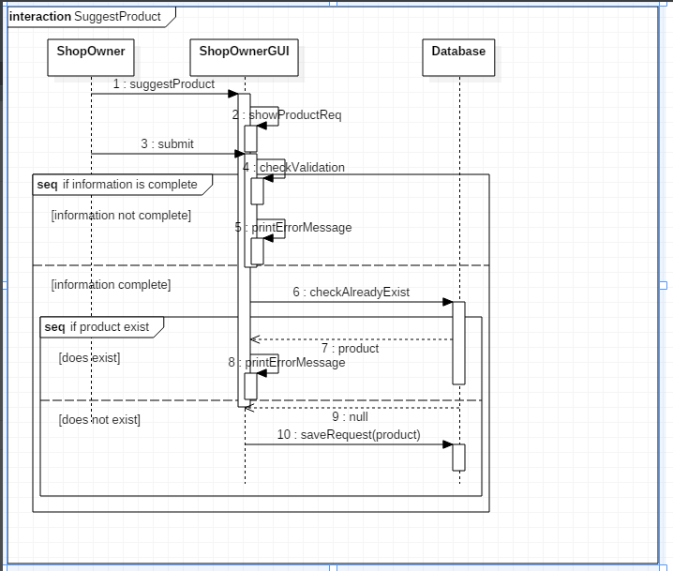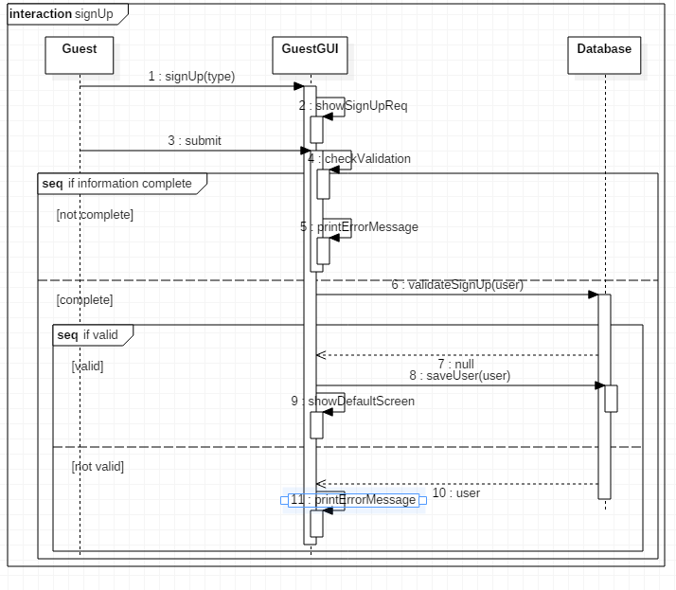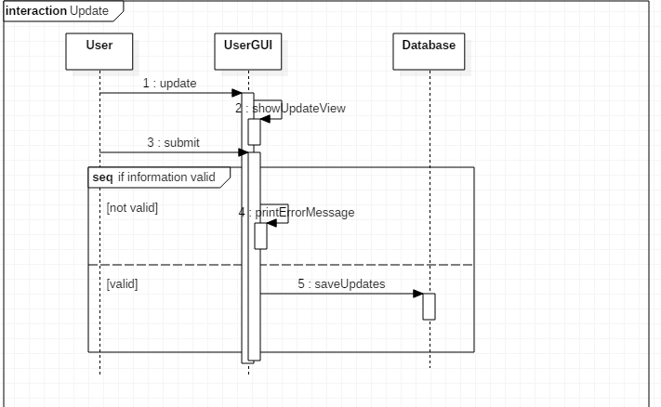

### Class - Sequence Usage Table

| **Class Name** | **Sequence Diagrams** | **Overall used methods** |
| --- | --- | --- |
| Admin | addProduct, approve, removeProduct. | addProduct, seeRequests, removeProduct |
| AdminGUI | addProduct, approve, removeProduct | showProductReq, printErrorMessage, checkAlreadyExist |
| Database | addProduct, approve, removeProduct, buy, search, signin, signUp, stat, suggest, Update | checkValidation, saveProduct, getRequests, removeFromRequests, deleteProduct, checkUser, validateSignUp, saveRequest, saveUpdates, applyBuy |
| CustomerGUI | Buy | Buy, submitPay, |
| UserGUI | Search, stat, update | Search, showStatisticsView |
| GuestGUI | Signin, signup | signIn(),signUp(),submit() ,ShowSignUpReq(), checkValidation(), printErrorMessage(), showDefaultScreen(), |
| ShopOwnerGUI | Suggest | suggestProduct,showProductReq, |
| Searching | Search, stat | validateSearch, |
| Customer |  |  |
| User |  |  |
| Guest |  |  |
| Controller | SignIn | changeState(user),loadUser(user),endUser() |
| ShopOwner |  |  |

# References

* http://www.mhhe.com/engcs/compsci/pressman/graphics/Pressman5sepa/common/cs1/design.pdf

# Authors

* Mostafa Saad and Mohammad El-Ramly (Edited by Mohamed Samir)